Y2Q2W5

Daniel

Ask: When you are sick do you feel like doing school work?
Ask: If you had to do a test when you were feeling sick, do you think you would do very well?

Say: God doesn't want us to be sick. He wants us to be healthy and to do well. Today we are learning about one of my favourite people in the Bible, and we are learning how he chose to do things Gods way, so that he would have a good mind and body.

Bible Story - DVD

Sing Songs

Ask: Why didn't Daniel want to eat the king's food? (Idols / unhealthy)

Return to tables
Memory Verse: Fill in the blanks and then say the memory verse on the colouring page and finish.

Say: This term we are going to make fridge magnets to tell the Bible stories with. You will keep your magnets in a special magnet book which we will loan to you until the end of the term and then you can take the magnets home – but we will keep the magnet books for next time. DO NOT DRAW OR WRITE ON THE MAGNET BOOKS

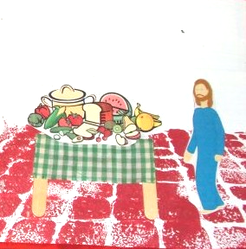
Magnet Books
- If they haven't already: Choose a magnet book. Write your name on a label and loop through handle. Hand out king, crown and prophet
- Hand out platter of food – and put a magnet on the back
- Tape cardboard or material top onto table legs and put a magnet on the back of each leg.

Discuss the following depending on age, interest and time:
What bad things might have happened to Daniel when he asked about changing their food? (Prison, death?)
What would have happened if Daniel ate the food? (Blessed by idols, would have seemed like he was worshiping the idols, rich, fatty or sweet food make us sleepy and makes it harder to think clearly. Lots of vegetables are needed to give the proper nutrients so our brain and body will grow and work properly etc.)
Would it have hurt Daniel to eat it just once? (Not really, but the man in charge might then be less likely to listen to their request and having eaten it once it would be easier to eat a second time until they wouldn't worry about it any more.)
What choices can you make to be healthy or unhealthy?
Think about the adds you see on TV – are they for healthy or unhealthy things?
Look at what God gave people to eat after creation, and after sin.
Talk about contamination of the environment and depletion of soils. (Food is not as healthy now as in the past)

Activity 2:
Handout: The A5 page of food and things. Cut them apart and then glue them on the appropriate area of the have lots / have never page.

If they want they may put a small magnet on the back to take home to put on the fridge.

Say: I hope that you remember Daniel, next time you want to ask Mum for sweets when she's shopping. – And when you're old and someone offers you a cigarette or drugs or alcohol.

Say: When you choose to eat healthy food – lots of fruit and vegetables – your body grows a lot stronger and your brain is a lot smarter.

Pray: That God will help them to make healthy choices like Daniel did.

